- Parking:
  - Use the East parking garage (the one on the right if you’re looking at the river).
  - Get a ticket, the Galt House will validate our parking so we don’t have to pay (ask for validation before you leave)
- Conference Rooms:
  - We’ll be doing the October lesson in the Sampson room
  - The rest of the lessons will be in the Carol Ford room
    - The directions for how to get to the Carol Ford room are at the end of this document
- IT Setup:
  - There should usually be someone from the tech committee at the lesson, but if not, just make sure someone has an HDMI cord and their laptop so the lesson can be shown on the projector.
  - The Galt House is providing the screen and projector we’ll be using for the lesson for now, but the trauma team should be purchasing one that we can use for next year so we don’t have to pay the Galt House IT fee for every lesson.
    - For October 2021-December 2021, the Galt House is giving us the conference room and IT setup for free because they get to write this cost off on their taxes since they’re working with a non-profit (Christopher 2X Game Changers). For January 2022 and on, the Galt House is charging Game Changers 1/10 of the normal price for use of the conference room + IT setup
- Storage of Supplies For Lessons:
  - In progress
  - Hopefully the Trauma Institute has space to store the supplies

Directions To The Carol Ford Room

The Carol Ford Room is located in the East building (the one to the right if you’re looking at the river). If you’re in the East Building lobby, you can see the Carol Ford Room and the staircase you use to get to it.
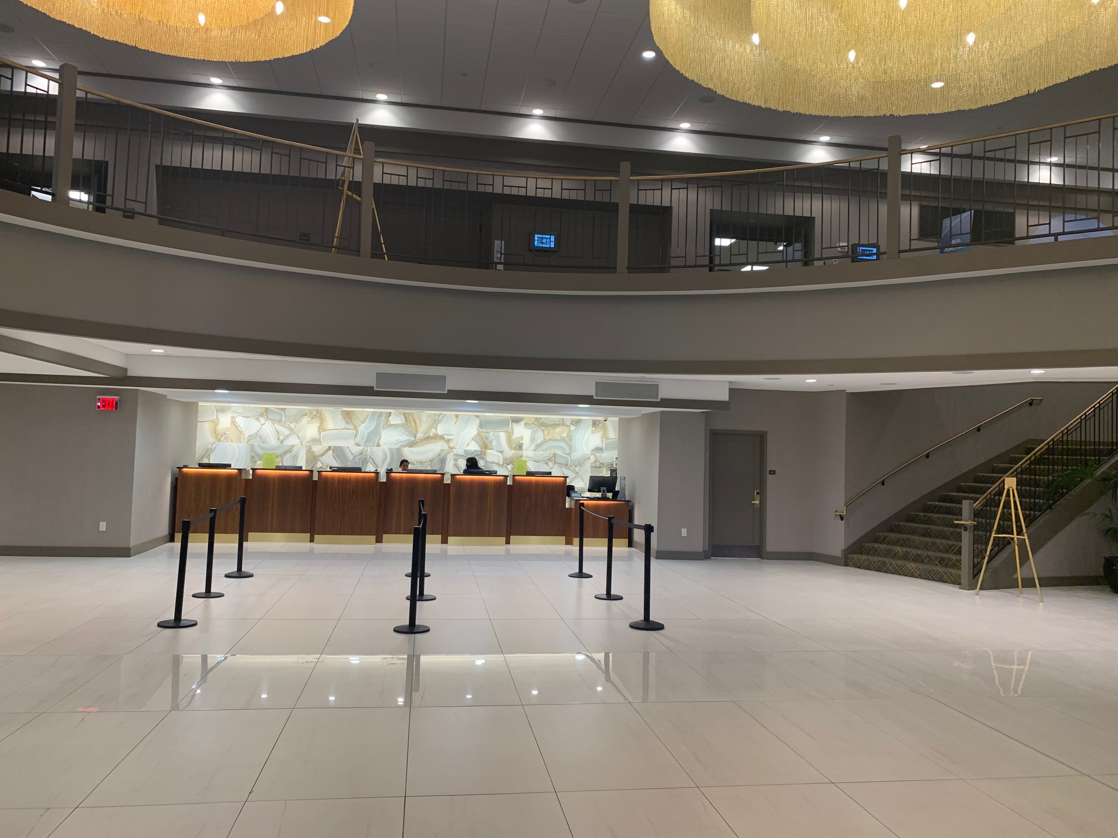

This is the Carol Ford Room.

