Home Sleep Apnea Test (HSAT)
Application Instructions

As with any medical procedure, if at any point you feel you are having a medical emergency, please contact 9-1-1 emergency services immediately.
There are three sensors you will be applying:
- An Effort Belt to measure your breathing effort.
- A Nasal Cannula to measure the airflow through your nose.
- A Pulse Oximeter – a small rubber sheath that fits onto the end of your finger to measure the oxygen in your blood and your heart rate using an infrared light.
The Alice NightOne device will automatically power on and begin recording when the effort belt is connected.

Attaching the Sensors:
The Alice NightOne device should be worn over clothing.

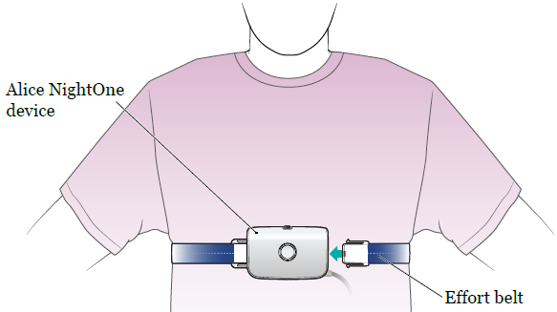
Effort Belt

- Wrap the effort belt around your chest so the Alice NightOne device is in the center of your chest. The effort belt should be evenly across your nipples or above your breasts. The belt should be snug but not too tight.

- Plug the loose end of the effort belt into the Alice NightOne device. After the effort belt is connected, the good study indicator will blink green as the device automatically turns on and starts recording.

- Once the device is turned on, the effort belt icon will appear. It will probably be flashing yellow. Use the buckle on the effort belt to adjust the belt so it’s snug but not uncomfortable.

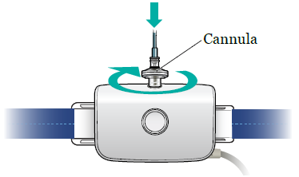
Nasal Cannula
- Twist the cannula clockwise (to the right) to connect it to the top of the Alice NightOne device.

- Hold the nasal cannula tube in front of your face. Check that the prongs on the tube curve slightly toward you. Then, gently place the prongs into your nose. One prong should go into each nostril.

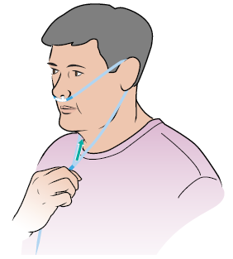
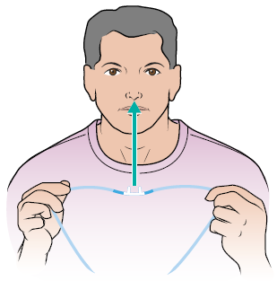
- Take several breaths with the nasal cannula in place. The nasal cannula icon on the device should turn green. If it doesn’t, make sure the prongs are inside your nostrils. Breathe through your nose for 10 seconds, then check the icon again. Tape the nasal cannula down on each cheek.

Pulse Oximeter
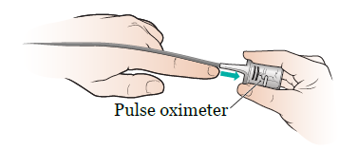
- Put the rubber sensor on one of your index (pointer) fingers. The pulse oximeter only works on a natural, clean nail. If you have a fake nail or are wearing nail polish, remove this before putting on the pulse oximeter.

- Place the sensor so the wire goes over the back of your hand.

- Take several breaths with the pulse oximeter in place. The pulse oximeter icon should turn green. If it doesn’t, check the position of the sensor. Make sure it’s securely in place. Then, take a few more breaths and check the icon again.

Once all the sensors are connected and working properly, the three sensor icons and the good study indicator will be solid green. After about a minute, the icons will start to turn off one by one. Once all the icons have turned off, the Alice NightOne device is ready. You may now go to sleep.

You can sleep in your usual position (such as on your back, side, or stomach) during your HSAT. Leave the Alice NightOne device and sensors on all night, even if you get up to use the restroom. If any of the sensors slip off or move during the night, put them back on. You don’t need to stop your HSAT. If any of the device icons are flashing yellow, adjust sensor until it turns green and goes off.

How to End Your HSAT

Disconnect one side of the belt from the Alice Night One device and take the nasal cannula and pulse oximeter off your body. The device will turn off automatically, usually within 30 minutes.

For Night 2 of your HSAT, replace the batteries provided and reapply the sensors to start the test.

Returning the HSAT Equipment

The morning after your second test, please put equipment back in the carrying case provided and return to the Sleep Lab.

Patient Responsibility/Agreement
I have received instructions for the use of the HSAT device and accept responsibility for the return of undamaged equipment. If the unit is not returned or is damaged, I accept responsibility for the cost of repair/replacement.
- I will take my HSAT test for two nights on the following date(s):
___/___/___ ___/___/___
- I will return/mail my device on ___/___/___
________________________________________ ___/___/___
Patient Name/Signature Date

Please call 502-259-6611 with questions about your HSAT or for more information.

